PROJECT WORK

"Verilog Implementation of Digital Circuit Designs on FPGA using Vivado"

Topic: Traffic Light Controller Design using Verilog

Made by:Kushagra Tripathhi
Motilal Nehru National Institute of Technology,
Electronics and Communication Engineering .
Semester:6

PROBLEM STATEMENT
The aim of the project is to design a traffic controller for a T-intersection. Let’s understand the problem statement through the image given below.
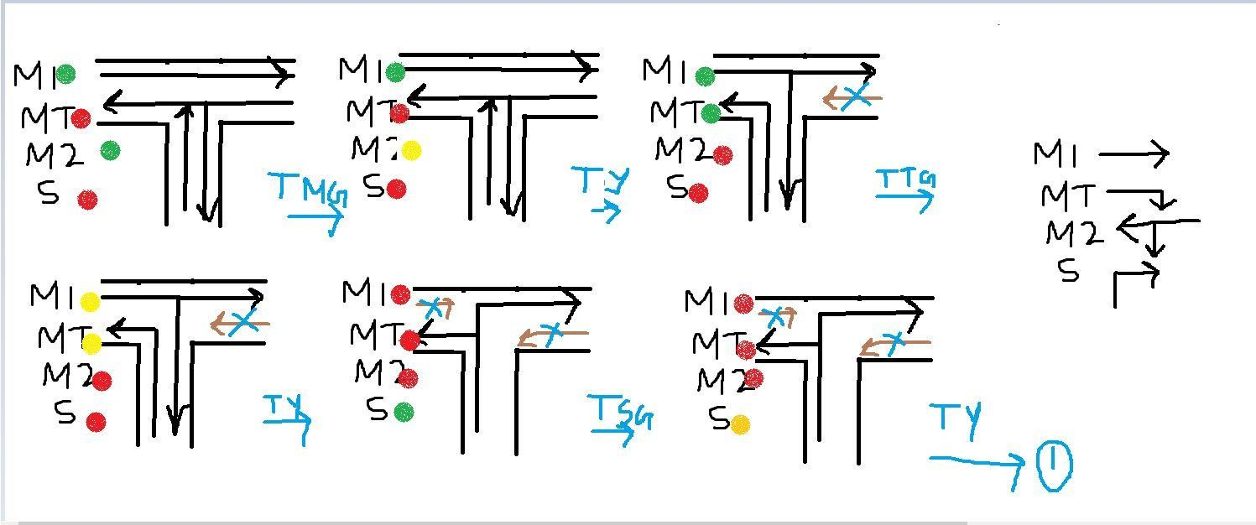
The six cases present here eventually turn to the six states . This is the state diagram:

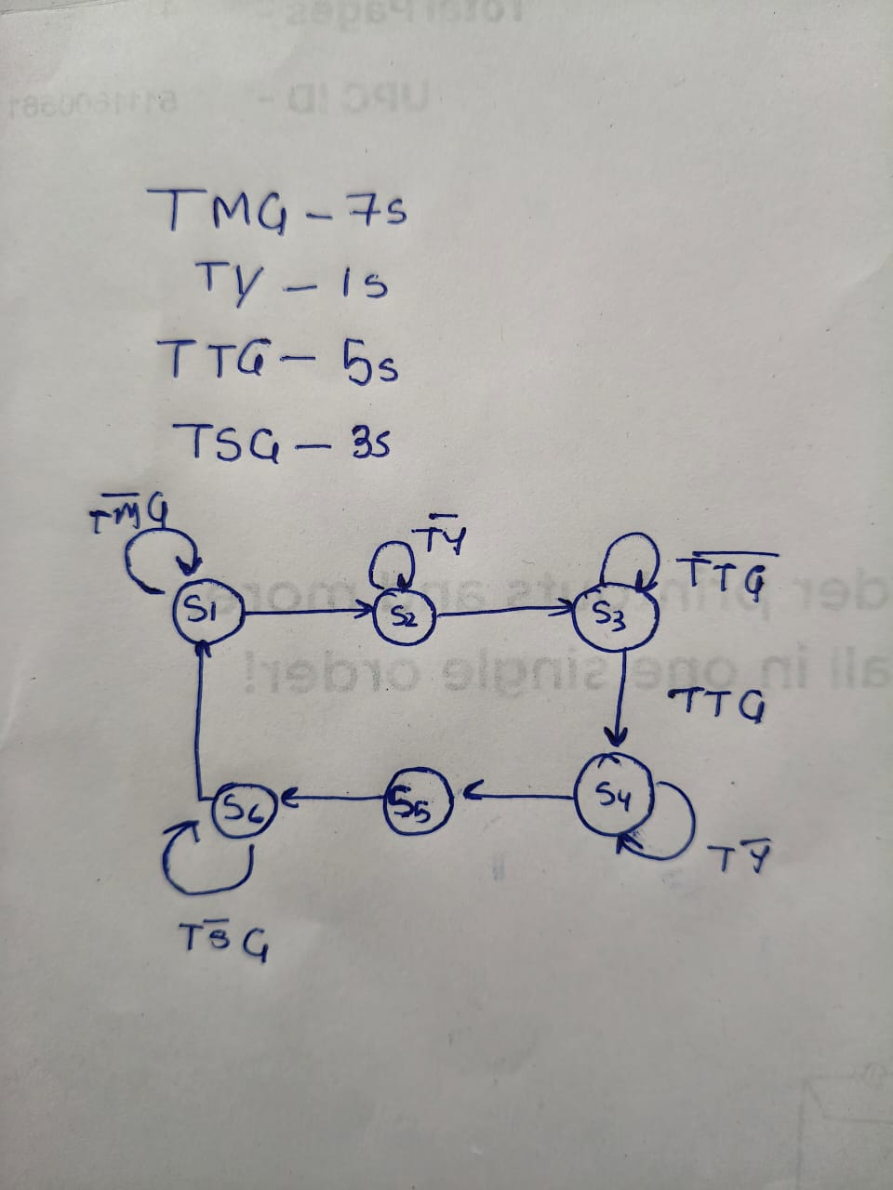
From the state diagram we for the state table:

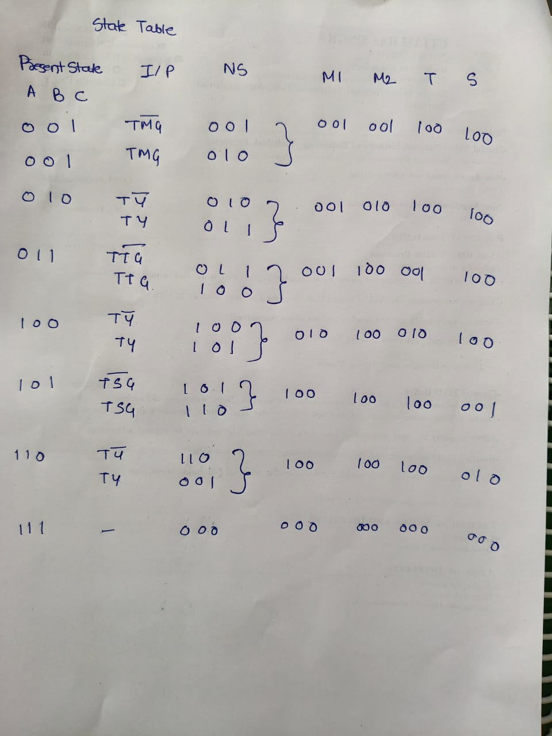

VERILOG CODE
`timescale 1ns / 1ps

module Traffic_Light_Controller(

input clk,rst,
output reg [2:0]light_M1, output reg [2:0]light_S, output reg [2:0]light_MT,

output reg [2:0]light_M2
);

parameter S1=0, S2=1, S3 =2, S4=3, S5=4,S6=5;
reg [3:0]count; reg[2:0] ps;
parameter sec7=7,sec5=5,sec2=2,sec3=3;

always@(posedge clk or posedge rst) begin
if(rst==1) begin ps<=S1;
count<=0; end
else

case(ps)
S1: if(count<sec7) begin ps<=S1;
count<=count+1; end
else
begin

ps<=S2;
count<=0; end
S2: if(count<sec2) begin ps<=S2;
count<=count+1; end

else
begin ps<=S3;
count<=0; end
S3: if(count<sec5) begin ps<=S3;
count<=count+1; end

else
begin ps<=S4;
count<=0; end
S4:if(count<sec2) begin ps<=S4;
count<=count+1; end

else
begin ps<=S5;
count<=0; end
S5:if(count<sec3) begin ps<=S5;
count<=count+1; end

else
begin ps<=S6;
count<=0; end

S6:if(count<sec2) begin ps<=S6;
count<=count+1; end

else
begin ps<=S1;
count<=0; end
default: ps<=S1;

endcase end

always@(ps) begin
case(ps)

S1:
begin
light_M1<=3'b001; light_M2<=3'b001; light_MT<=3'b100; light_S<=3'b100;
end S2:
begin
light_M1<=3'b001; light_M2<=3'b010; light_MT<=3'b100; light_S<=3'b100;
end S3:
begin
light_M1<=3'b001; light_M2<=3'b100; light_MT<=3'b001; light_S<=3'b100;
end S4:
begin

end

endmodule
light_M1<=3'b010; light_M2<=3'b100; light_MT<=3'b010; light_S<=3'b100;
end S5:
begin
light_M1<=3'b100; light_M2<=3'b100; light_MT<=3'b100; light_S<=3'b001;
end S6:
begin
light_M1<=3'b100; light_M2<=3'b100; light_MT<=3'b100; light_S<=3'b100;
end default:
begin
light_M1<=3'b000; light_M2<=3'b000; light_MT<=3'b000; light_S<=3'b010;
end endcase

RTL-SCHEMATIC
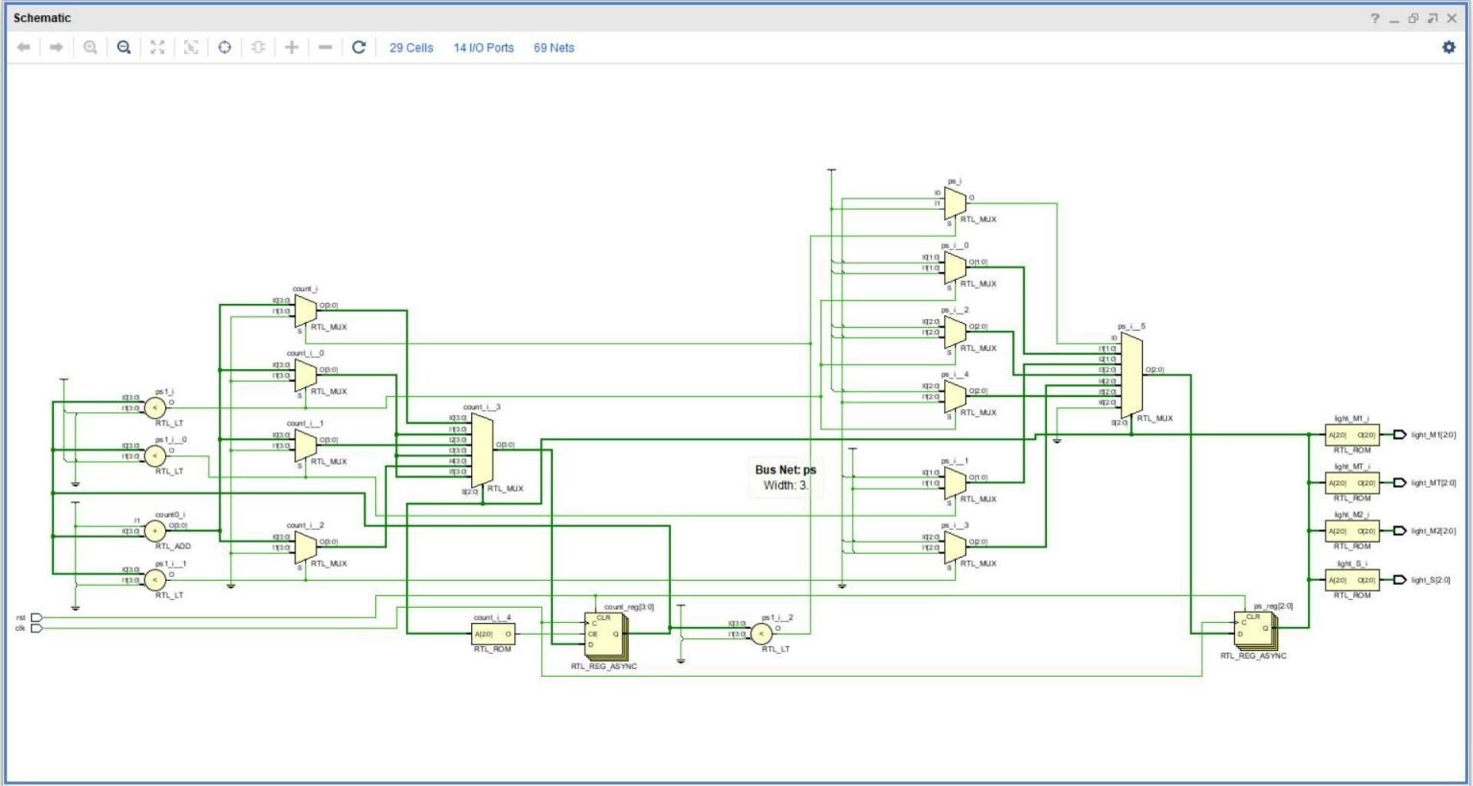
TESTBENCH
`timescale 1ns / 1ps
//////////////////////////////////////////////////////////////////////////////////
// Company:
// Engineer:
//
// Create Date: 16.07.2020 23:44:40
// Design Name:
// Module Name: Traffic_Light_Controller_TB
// Project Name:
// Target Devices:
// Tool Versions:
// Description:
//
// Dependencies:
//
// Revision:

// Revision 0.01 - File Created
// Additional Comments:
//
//////////////////////////////////////////////////////////////////////////////////

module Traffic_Light_Controller_TB; reg clk,rst;
wire [2:0]light_M1; wire [2:0]light_S; wire [2:0]light_MT; wire [2:0]light_M2;
Traffic_Light_Controller dut(.clk(clk) , .rst(rst) , .light_M1(light_M1) , .light_S(light_S)
,.light_M2(light_M2),.light_MT(light_MT) ); initial
begin
clk=1'b0;
forever #(1000000000/2) clk=~clk; end
initial begin
rst=0; #1000000000;
rst=1; #1000000000;
rst=0; #(1000000000*200);
$finish; end
endmodule

SIMULATED WAVEFORM
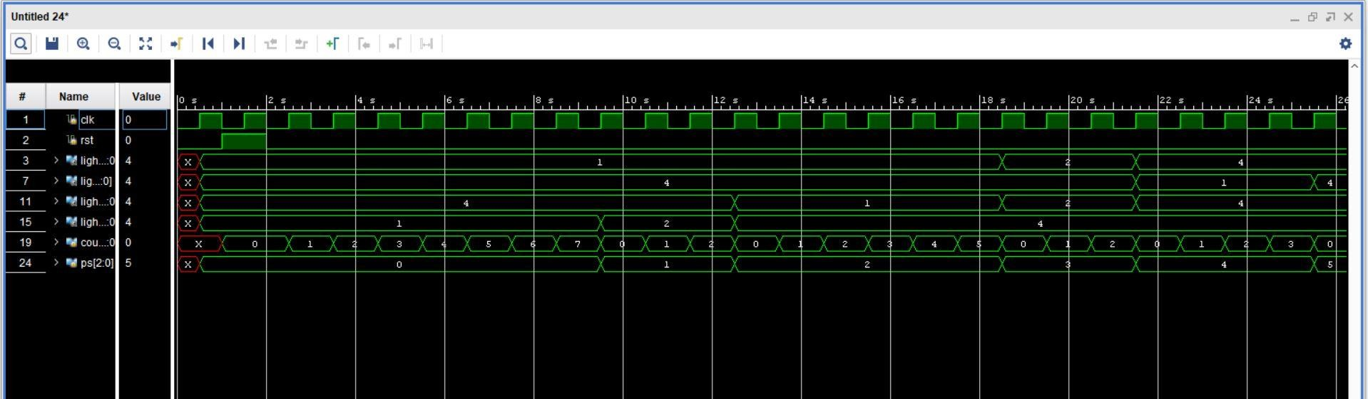
Upon analysing the waveform we can clearly see that the FSM works perfectly.

IO PORT ASSIGNMENT
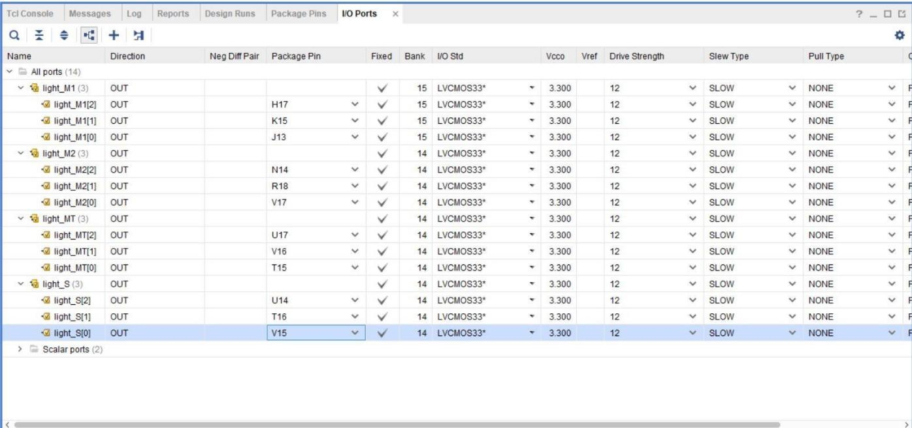
The ports are assigned from the ucf file .

